**PAPER – II PRACTICAL NO. : 01**

**AIM : IMPLEMENT IP SLA (IP SERVICE LEVEL AGREEMENT).**

**ROLL NO. : 02 BATCH : M.SC PART-I**

**DATE : 07/10/22**

**CODE :**

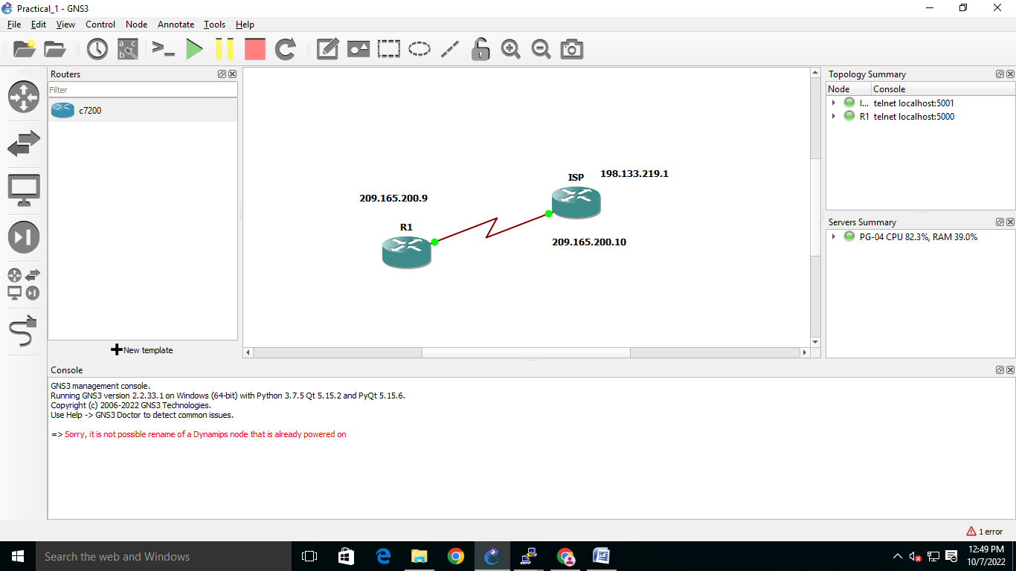

**ISP:**

ISP#en

ISP#conf t

Enter configuration commands, one per line. End with CNTL/Z.

ISP(config)#int s1/0

ISP(config-if)#ip address 209.165.200.10 255.255.255.252

ISP(config-if)#clock rate 4032000

ISP(config-if)#no ip domain-lookup

ISP(config)#int loopback 0

ISP(config-if)#

*Oct 7 12:13:00.539: %LINEPROTO-5-UPDOWN: Line protocol on Interface Loopback0, changed state to up

ISP(config-if)#ip address 198.133.219.1 255.255.255.255

ISP(config-if)#exit

ISP(config)#end

ISP#

*Oct 7 12:13:25.587: %SYS-5-CONFIG_I: Configured from console by console

ISP(config)#int loopback 0

ISP(config-if)#no shutdown

ISP(config-if)#exit

ISP(config)#XXTTEERRMpp

**R1:**

R1#en

R1#conf t

Enter configuration commands, one per line. End with CNTL/Z.

R1(config)#hostname R1

R1(config)#int s1/0

R1(config-if)#ip address 209.165.200.9 255.255.255.252

R1(config-if)#no shutdown

R1(config-if)#

*Oct 7 12:09:10.947: %LINEPROTO-5-UPDOWN: Line protocol on Interface Serial1/0, changed state to down

R1(config-if)#ip route 0.0.0.0 0.0.0.0 209.165.200.10

R1(config)#

*Oct 7 12:14:00.947: %LINEPROTO-5-UPDOWN: Line protocol on Interface Serial1/0, changed state to up

R1(config)#ip sla 22

R1(config-ip-sla)#icmp-echo 198.133.219.1

R1(config-ip-sla-echo)#frequency 20

R1(config-ip-sla-echo)#exit

R1(config)#ip sla schedule 22 start-time now life forever

R1(config)#end

R1#show ip sla configuration

**OUTPUT :**

R1#show ip sla configuration

IP SLAs Infracture Engine-III

